Swift Scribe (PDF Summarizer)

A Minor Project Synopsis
Submitted in Sixth Semester of Bachelor of Technology (B-Tech)

In Computer Science & Engineering (Session: 2023-24)



Submitted By Under the Guidance of
Name Prince Gupta Prof. Prateek Gupta ( Professor)
Enroll No: 0213CS211074 (Computer Sc. & Engg.)

Name Ashima Singh

Enroll No: 0213CS211022

Name Sweta Ghoshi

Enroll No: 0213CS211120

DEPARTMENT OF COMPUTER SCIENCE & ENGINEERING
Shri Ram Institute of Science & Technology, Jabalpur(M.P.)
Rajeev Gandhi Proudyogiki Vishwavidyalaya, Bhopal (M.P.)

CERTIFICATE
This is to certify that
Name1 Prince Gupta Roll No 0213CS211074
Name2 Ashima Singh Roll No 0213CS211022
Name3 Sweta Ghoshi Roll No 0213CS211120

Students of 6th semester, Computer Sc. & Engg. S.R.I.S.T., Jabalpur have submitted their minor project entitled “Swift Scribe (PDF Summarizer)” for the completion of 6th semester examination under the requirement for the degree of Bachelor of Technology as per R.G.P.V., Bhopal.

Project Guide HOD
Prof. Prateek Gupta Prof. Prateek Gupta
(Professor) ( Professor)
CSE, SRIST CSE, SRIST

Date:

Acknowledgement

The successful completion of the Swift Scribe project would not have been possible without the support and guidance of many individuals.

First and foremost, we extend our heartfelt thanks to Prateek Sir, whose invaluable insights and constructive feedback guided us through every stage of development.

We are also grateful to the development community and contributors of open-source libraries, whose tools significantly enhanced our capabilities.

Lastly, we recognize the user community for whom this project was developed. Their needs and feedback have driven our efforts, and we are committed to continuing to improve and adapt Swift Scribe to better serve them.

Thank you to everyone who contributed to the success of Swift Scribe.

Prince Gupta Roll No 0213CS211074
Ashima Singh Roll No 0213CS211022
Sweta Ghoshi Roll No 0213CS211120

INDEX

S.No. | TOPICS | PAGE NO.
1. | INTRODUCTION
2. | ANALYSIS  - Objective  - Working  - Software Requirement Specification  - Software Engineering Paradigm  - PERT Chart  - GANTT Chart  - Software Development Life Cycle
3. | DESIGN  - Algorithm & Flow Chart  - Design of Data Base iii.UML Diagram  - DFD  - Class Diagram  - Activity Diagram  - ER Diagram  - Control Flow Diagram  - System Flow Diagram
4. | TOOLS DESCRIPTION
5. | RESULT
6. | TESTING
7. | CONCLUSION
8. | REFRENCES

Introduction:

Overview:
The project aims to create a complete, functional SaaS platform that allows users to upload PDFs, extract and process the content, and interact with the information through a chat interface.

Problem Statement:
Problem: Businesses and individuals often struggle with efficiently managing and extracting information from PDF documents. Manually reading and summarizing PDFs can be time-consuming and tedious.
Solution: The SaaS platform aims to address this by providing an automated solution for processing and summarizing PDF content. Users can upload PDFs, and the platform utilizes AI to extract key information and answer user questions about the document in real-time.
Here's a breakdown of how the platform might solve the problem:
- Reduced Manual Work: Users don't need to spend time manually summarizing or searching through PDFs.
- Improved Efficiency: The platform can process and summarize documents quickly, saving users time.
- Enhanced Information Access: Users can easily access and understand the key points of a PDF through summaries and interactive Q&A.
- Scalability: The platform can handle a large volume of PDFs, making it suitable for businesses with extensive document management needs.

Scope:
The project aims to develop a SaaS platform encompassing core functionalities such as a landing page, pricing page, secure authentication, user dashboard, PDF uploading, chat interface, and real-time AI summarization. Exclusions include advanced user management and complex billing features. The report acknowledges the possibility of further refinement based on project goals and user feedback, emphasizing the video's specific focus.

Analysis:

Objective of Project:

The objective of the project is to Develop a functional SaaS platform that allows users to upload PDFs, extract and analyze their content, and interact with the information through a chat interface.
Here's a breakdown of the key functionalities aimed for in the project:
- PDF Upload: Users can upload PDF documents to the platform.
- Content Extraction: The platform parses and extracts relevant information from the uploaded PDF, such as text, tables, and potentially structured data.
- Data Processing (Optional): Depending on the video's approach, the platform might process the extracted data for further analysis or visualization.
- Large Language Model Integration (Optional): The video might utilize a Large Language Model (LLM) like OpenAI to answer user questions about the uploaded PDFs.
- Chat Interface: Users can interact with the platform through a chat interface. They can ask questions about the content of the uploaded PDF, and the platform will answer, potentially highlighting relevant parts of the document.
In essence, the project aims to create a user-friendly SaaS platform that empowers users to easily access and analyze information stored within PDF documents.

Working:
- Landing Page & Sign Up:
  - Users visit the landing page, which highlights the platform's features and benefits (e.g., real-time AI-powered summarization).
  - Users can sign up for a free account or choose a paid plan with more features.
- PDF Upload:
  - Users can upload a PDF document to the platform. The video mentions a limit on file size and number of pages depending on the subscription plan.
- Chat Interface:
  - After uploading the PDF, users can interact with the document through a chat interface.
- AI-powered Summarization:
  - The platform leverages an LLM (Large Language Model) like OpenAI to process the uploaded PDF and answer user questions in real-time.
  - The LLM analyzes the document and highlights relevant parts based on the user's query.
- Data Extraction & Search:
  - The platform likely extracts text, tables, and other relevant information from the PDF during upload.
  - This allows users to search for specific keywords or phrases within the document through the chat interface or a separate search functionality.
SRS :

1. Introduction
- 1.1 Project Title: Building a Complete PDF SaaS Platform
- 1.2 Description: This document outlines the requirements for a Software as a Service (SaaS) platform that allows users to upload, process, and extract information from PDF documents.
2. Overall Description
- 2.1 Product Perspective: This platform is designed for users who need to extract information from PDFs quickly and easily. It can be used by individuals, businesses, and organizations.
- 2.2 Product Functions:
  - Upload PDF documents.
  - Process and index the content of uploaded PDFs.
  - Allow users to ask questions about the uploaded PDFs.
  - Answer user questions by highlighting relevant sections within the PDF document.
  - Provide summaries of key points in the PDF document.
  - Secure user authentication and authorization.
  - Implement a responsive design for access from any device.
- 2.3 User Characteristics: The target users include:
  - Students and researchers working with academic papers.
  - Professionals dealing with contracts, reports, and other documents.
  - Business owners analyzing market research reports and financial documents.
3. Specific Requirements
- 3.1 Functional Requirements:
  - 3.1.1 Uploading and Processing:
    - The platform should allow users to upload PDF documents with a maximum file size of X MB (specify the limit mentioned in the video).
    - The platform should be able to process various PDF formats, including text-based PDFs and scanned documents.
    - The platform should extract text, tables, and other relevant information from the uploaded PDFs.
  - 3.1.2 User Interaction:
    - Users should be able to ask questions about the uploaded PDF documents .
    - The platform should provide answers to user questions, highlighting the relevant sections within the PDF.
    - The platform should offer different answer formats, such as summaries and bullet points (as mentioned in the video).
  - 3.1.3 Security:
    - The platform should implement secure user authentication to protect user data.
    - The platform should encrypt uploaded PDF documents and user data at rest and in transit.
  - 3.1.4 User Interface:
    - The platform should have a user-friendly and responsive interface that is accessible from various devices (desktop, mobile).
    - The interface should be designed for ease of use with clear instructions and intuitive navigation.
- 3.2 Non-Functional Requirements:
  - 3.2.1 Performance:
    - The platform should be able to process and answer user queries within a reasonable timeframe (mention the specific timeframe mentioned in the video, if any).
    - The platform should be scalable to handle a growing number of users and uploaded documents.
  - 3.2.2 Availability:
    - The platform should be available to users 24/7 with minimal downtime.
    - The platform should have a disaster recovery plan to ensure data integrity and service continuity.
  - 3.2.3 User Experience:
    - The platform should be easy to learn and use with minimal learning curve.
    - The platform should provide clear and helpful feedback to users.

Feasibility Study for the Project:

1. This feasibility study explores the potential of building a SaaS platform that allows users to upload, process, and interact with PDF documents using advanced features like real-time AI-powered summarization and chat-based question answering. The study evaluates the technical feasibility, market viability, and economic viability.
Technical Feasibility:
- Technology Stack: The chosen technologies (Next.js 13, React, Prisma, tRPC, and Tailwind CSS) are all mature and well-suited for building modern web applications. Developers familiar with these technologies can build the platform efficiently.
- Open Source Libraries: The video demonstrates the utilization of open-source libraries like OpenAI for the LLM functionalities. This reduces development costs and leverages existing solutions.
- Complexity: While the platform offers advanced features, the video provides a step-by-step approach, suggesting the technical implementation has a moderate level of complexity.
Market Viability:
- Market Need: There is a growing demand for tools that can simplify PDF processing and information extraction. Platforms offering AI-powered functionalities like summarization and question answering can be valuable for various industries like education, research, and legal services.
- Competition: While there are existing PDF processing tools, the focus on AI-powered summarization and chat-based interaction could create a competitive advantage for this platform.
- Target Market: The target audience could include students, researchers, professionals working with large volumes of documents, and anyone who needs to efficiently extract information from PDFs.

Economic Viability:
- Cost of Development: Utilizing open-source technologies minimizes upfront development costs. However, potential costs include cloud hosting, subscriptions for services like OpenAI, and ongoing maintenance.
- Revenue Model: The platform can offer a freemium model with limited features and paid plans with increased functionalities and storage quotas.
- Potential Challenges: User acquisition and establishing brand recognition in a competitive market could be initial challenges.

Software Engineering Paradigm: Agile Development:

Overview:
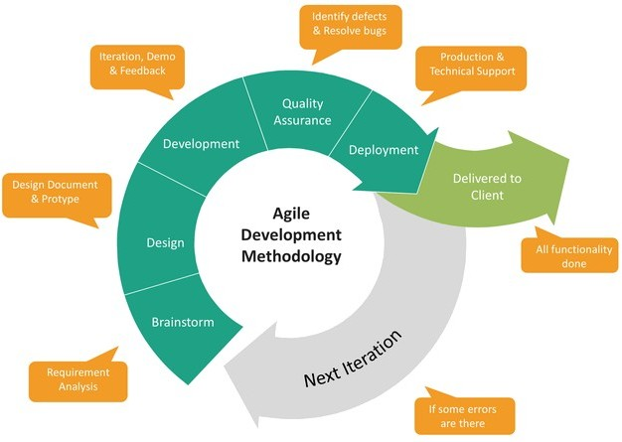
The project adopts the Agile software development paradigm, an iterative and incremental approach to software development. Agile methodologies prioritize flexibility, collaboration, and responsiveness to change, enabling teams to deliver high-quality software efficiently and adapt to evolving requirements and user needs.
Key Principles:
1. Iterative Development: The project is divided into small, manageable iterations or sprints, typically lasting 1-4 weeks. Each sprint focuses on delivering a set of prioritized features or user stories, allowing for rapid feedback and iteration.
2. Continuous Feedback: Stakeholder feedback is solicited and incorporated throughout the development process, ensuring alignment with user expectations and project goals. Regular demos and reviews facilitate open communication and collaboration.
3. Adaptive Planning: Requirements and priorities are subject to change, and the project adapts accordingly. The development team remains responsive to feedback, emerging requirements, and market dynamics, adjusting plans and priorities as needed.
4. Cross-functional Teams: The project team consists of cross-functional members, including developers, designers, testers, and domain experts. Collaboration and communication between team members are encouraged to foster shared understanding and collective ownership.
5. Incremental Delivery: Working software is delivered incrementally at the end of each sprint, providing tangible value to users and stakeholders early in the development process. This allows for quick validation of assumptions and enables course correction as needed.
6. Continuous Improvement: The Agile mindset emphasizes continuous improvement and learning. Retrospectives are held at the end of each sprint to reflect on what went well, what could be improved, and actions to take in the next iteration.
7. Empirical Process Control: The project management approach is empirical, relying on transparency, inspection, and adaptation. Progress is measured based on working software, and decisions are informed by empirical data and feedback.

Software Development Life Cycle (SDLC) :

Overview:
The project follows an iterative and incremental Software Development Life Cycle (SDLC) model, combining elements of Agile methodologies with traditional development practices. This approach allows for flexibility, adaptability, and continuous improvement throughout the project lifecycle, ensuring the timely delivery of high-quality software that meets user needs and expectations.

Phases of the SDLC:

1. Planning and Requirements Gathering:
- Define the problem the SaaS platform will solve (e.g., summarizing and searching PDFs through an AI interface).
- Identify the target audience for the platform.
- Gather user requirements through surveys, user interviews, or competitor analysis.
- Define the features and functionalities of the platform based on the collected requirements.
2. Design and Architecture:
- Choose the development technologies based on project needs (Next.js 13, React, Prisma, tRPC, Tailwind CSS as mentioned in the video).
- Design the user interface (UI) and user experience (UX) for the platform.
- Define the system architecture, including data flow and interactions between different components.
3. Development and Implementation:
- Implement the platform features according to the design and chosen technologies.
- This might involve building the landing page, implementing user authentication, integrating the PDF processing logic, and connecting the LLM for answering user questions.
- Unit tests can be written to ensure individual components function correctly.
4. Testing and Integration Testing:
- Test the functionality of the platform manually using various scenarios and user interactions.
- Conduct automated tests to simulate user behavior and verify platform behavior consistently.
- Perform integration testing to ensure different components of the platform work together seamlessly.
5. Deployment and Monitoring:
- Deploy the platform to a cloud platform (not explicitly covered in the video but might be mentioned).
- Configure monitoring tools to track performance, uptime, and potential errors.
6. Maintenance and Updates:
- This stage involves addressing bug fixes, adding new features based on user feedback, and improving the platform based on usage data and performance metrics.

PERT Chart :
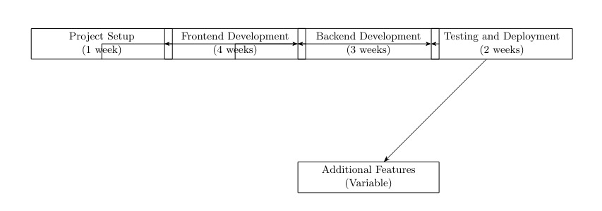

Gantt Chart :

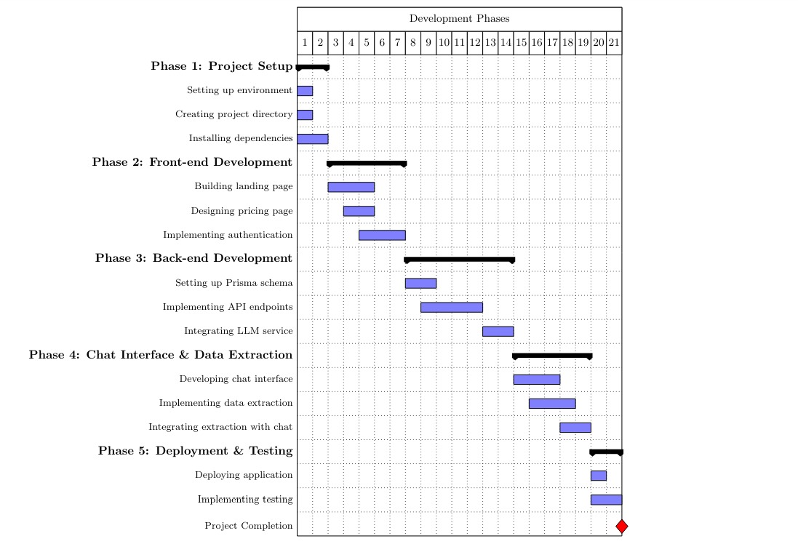

Design:

Algorithm and Flowchart :
1. Text Extraction and Parsing:
- This likely involves algorithms like Optical Character Recognition (OCR) to convert scanned text from PDFs into machine-readable format.
- Additional parsing algorithms might be used to identify different elements within the PDF like headings, paragraphs, tables, etc.
2. Information Retrieval:
- When a user asks a question about the PDF content, the platform needs to search and retrieve relevant information. This could involve algorithms like:
  - Keyword Matching: Matching user queries with keywords extracted from the PDF text.
  - Information Retrieval Models: More sophisticated models like TF-IDF (Term Frequency-Inverse Document Frequency) could be used to rank the relevance of extracted information to the user's query.
3. Document Summarization (Optional):
- If the platform offers document summarization, algorithms like:
  - Extractive Summarization: Identifying and extracting key sentences from the PDF that best represent the content.
  - Abstractive Summarization: Using AI models to generate a concise summary that captures the main points of the document, potentially using techniques like sentence compression or paraphrasing.
4. Large Language Model (LLM) Integration :
- If the platform utilizes an LLM like OpenAI to answer user questions, the specific algorithms used by the LLM itself are beyond the scope of this analysis. However, the platform might involve algorithms for:
  - Query Formulation: Transforming the user's natural language question into a format understandable by the LLM.
  - Response Processing: Interpreting the LLM's response and presenting it to the user in a clear and concise way, potentially highlighting relevant parts of the PDF document.

Modular Description :

Modular Description:
The platform utilizes a modular architecture, meaning it's composed of independent, self-contained units that work together to achieve the overall functionality. Here's a breakdown of the key modules:
- Frontend: Built with Next.js 13 and React, this module handles user interactions, manages the user interface (UI), and displays the application's functionalities.
- API Layer: This layer, potentially implemented using tRPC, acts as a communication bridge between the frontend and backend services. It receives user requests from the frontend, interacts with the backend services, and returns the processed data to the frontend for display.
- Backend Services: This encompasses several modules working together:
  - Authentication: This module handles user registration, login, and authorization for accessing platform functionalities.
  - PDF Processing: This module handles uploading and processing PDF documents. It likely involves parsing the PDF content, extracting text and potentially other relevant information (tables, figures) for further use.
  - Data Storage: A database solution like Prisma might be used to store user data, uploaded PDF information, and potentially other relevant data.
  - Large Language Model (LLM) Integration: An LLM service like OpenAI could be used in this module. It receives user questions related to the uploaded PDFs and leverages its understanding of language to generate relevant answers, potentially highlighting the corresponding sections in the PDF document.
- Tailwind CSS: This CSS framework likely provides pre-built utility classes that simplify styling the user interface components of the platform.
Benefits of Modular Architecture:
- Maintainability: Independent modules are easier to maintain, update, and test.
- Scalability: Individual modules can be scaled independently to meet the demands of a growing user base.
- Reusability: Modules can be potentially reused in other projects with similar functionalities.
- Development Efficiency: Modular development promotes code organization and simplifies collaboration among developers.

Design of Data Base:
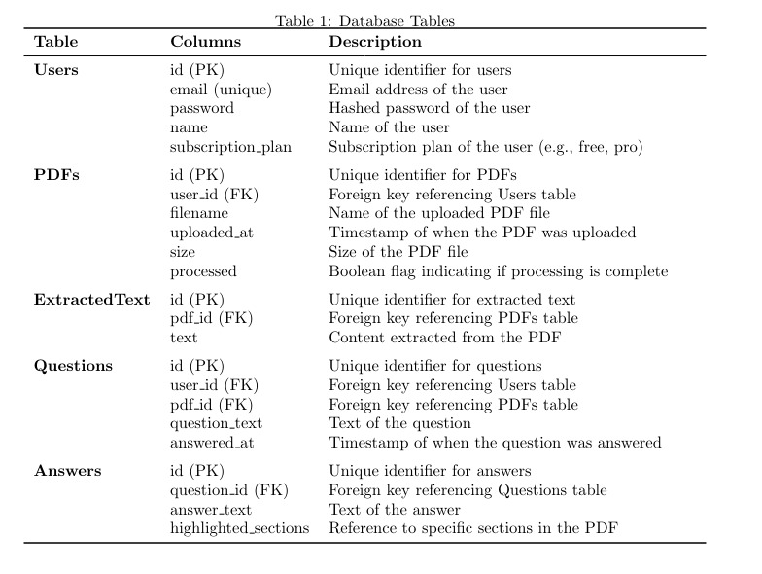UML Diagram :

DFD:
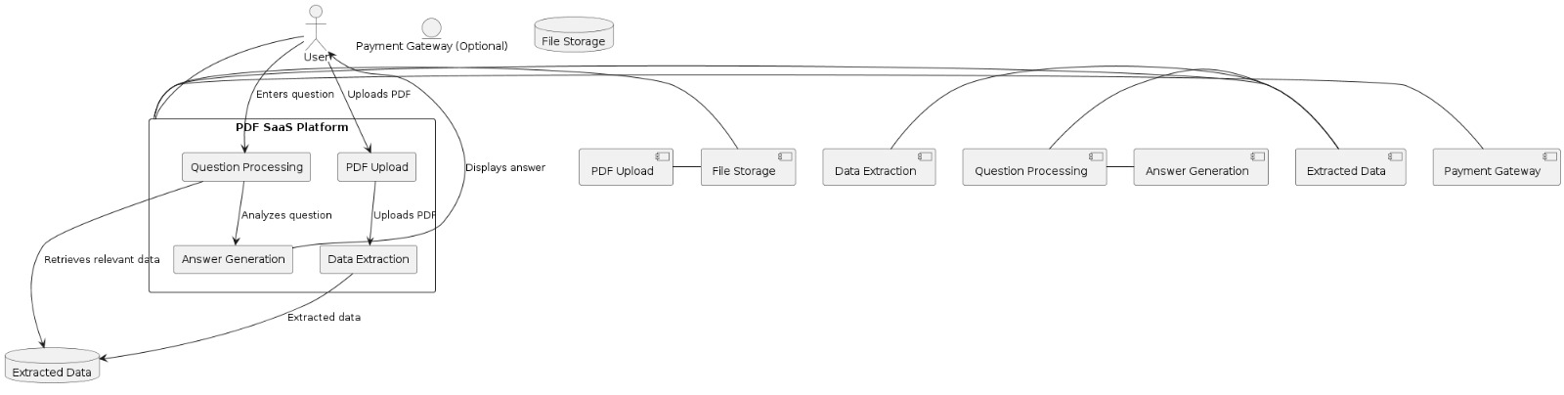

Class Diagram:
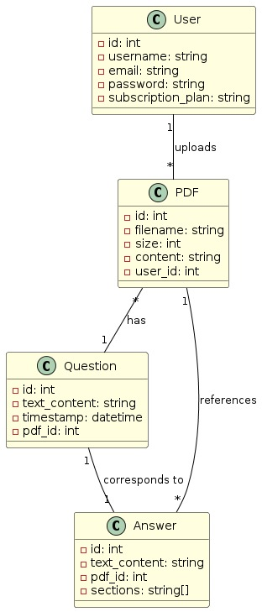
Activity Diagram :
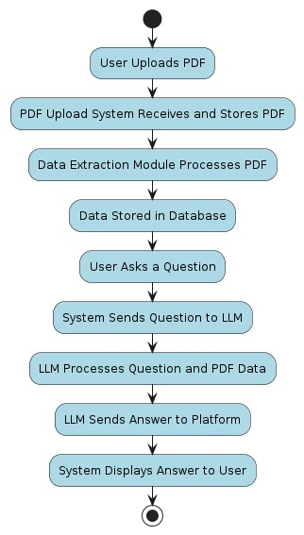

ER Diagram :

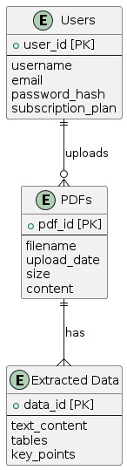
Control Flow Diagram:
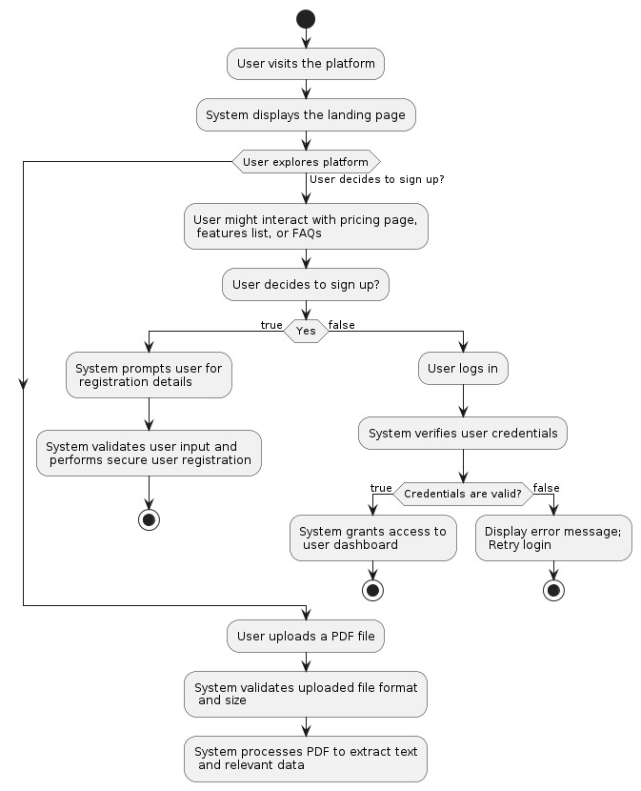

System Flow Diagram :

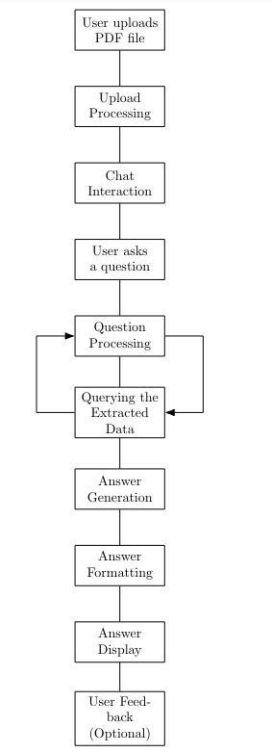

Implementation:

Tools Description :

Frontend Development:
- Next.js 13: A popular React framework for building server-rendered and statically generated web applications. It offers features like routing, data fetching, and code-splitting for performance optimization.
- React: A JavaScript library for building user interfaces. It allows developers to create reusable components and manage the state of the application.
- Tailwind CSS: A utility-first CSS framework that provides a wide range of pre-designed classes for styling web components. It allows for rapid development and customization.
Backend Development:
- Prisma: An open-source ORM (Object-Relational Mapper) that simplifies interactions with your database. It allows you to define data models and write queries in a type-safe way.
- tRPC: A type-safe RPC (Remote Procedure Call) framework that enables communication between the frontend and backend. It allows for efficient data transfer and improves maintainability.
Additional Tools (Optional):
- Node.js and npm (or yarn): Node.js is a JavaScript runtime environment used to run the application server-side. npm or yarn are package managers for installing and managing JavaScript dependencies.
- Git: A version control system for tracking code changes and collaborating with other developers.
- Code Editor: Tools like Visual Studio Code, Sublime Text, or Atom are commonly used for writing and editing code.

Process Logic of Modules :

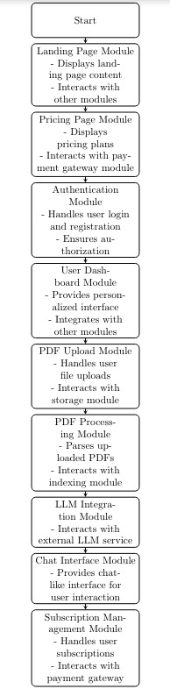

Result:
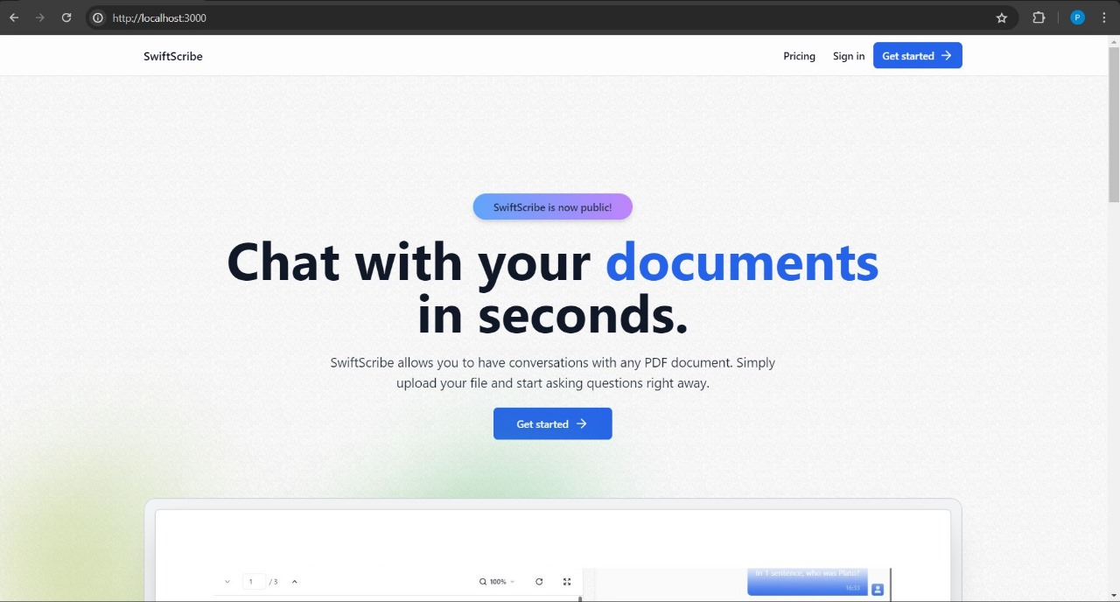

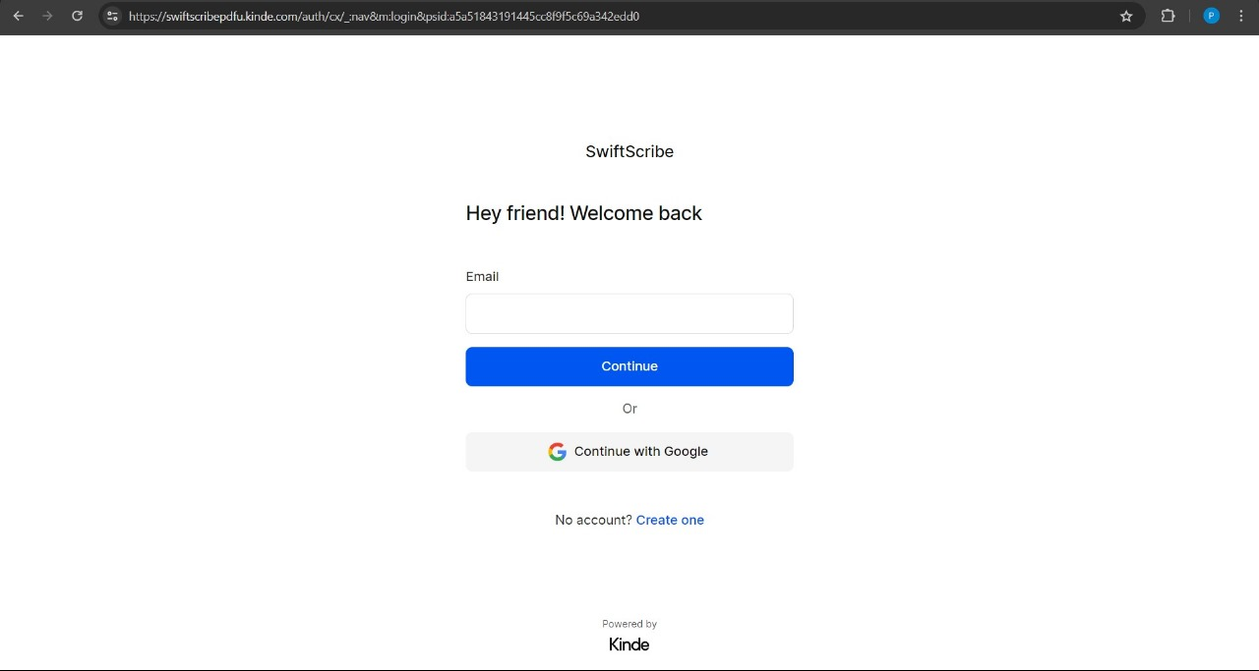

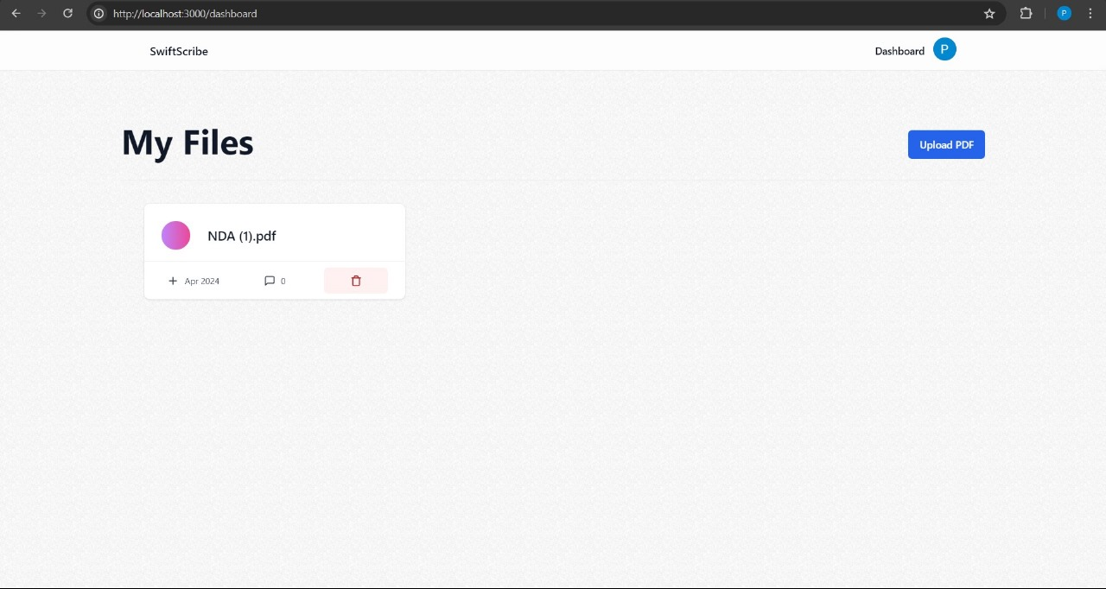

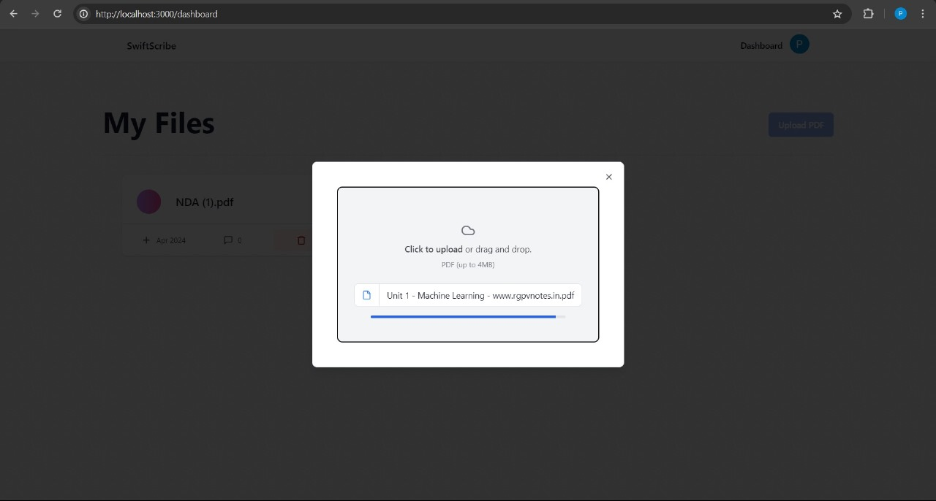

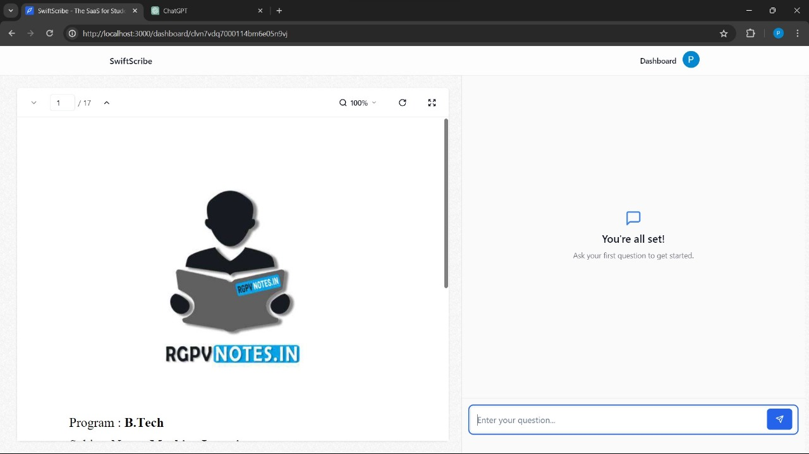

Testing:

Unit Testing for Swift Scribe Project

Unit testing is a software testing technique where individual units or components of a software system are tested. The purpose of unit testing is to validate that each unit of the software code performs as expected. In our Swift Scribe project, we use unit testing to test each module separately.

Test cases that have been applied in our project:

User Authentication:

1. Verify that valid user credentials allow access to the system.
2. Validate that invalid user credentials result in authentication failure.

PDF Upload and Processing:

1. Ensure that a new PDF can be uploaded successfully.
2. Verify that the uploaded PDF is validated correctly (file type, size).
3. Validate that the PDF content is accurately extracted and processed.

Text Extraction and Search:

1. Verify that text extraction from PDFs is accurate and complete.
2. Ensure that the search functionality correctly identifies and highlights relevant content within the extracted text.
3. Validate that queries are processed efficiently and results are returned promptly.

Question Answering Interface:

1. Verify that the user can submit a question about the uploaded PDF.
2. Ensure that the system sends formatted questions to the LLM service accurately.
3. Validate that the system correctly parses and displays answers from the LLM service.

Inventory Management (from the medical store management, adapted for managing PDFs):

1. Verify that the system accurately tracks the number of uploaded PDFs.
2. Validate that adding new PDFs updates the inventory count accordingly.
3. Ensure that deleting PDFs decreases the inventory count appropriately.

Sales Forecasting (adapted for predicting user interactions):

1. Verify that the user interaction forecasting algorithm predicts future usage accurately based on historical data.
2. Validate that forecasted user interactions align with actual user data over time.

Frontend Development:

Component Structure:

1. Verify that reusable UI components function correctly in isolation.
2. Ensure the landing page displays correctly and explains the platform’s purpose and features.
3. Validate that the upload section allows users to select and upload PDF files.
4. Verify that the chat interface functions correctly and enables users to ask questions about the uploaded PDFs.
5. Ensure that the answer display area shows the platform’s response to user queries accurately.

User Experience (UX) Design:

1. Verify that the interface is clean, intuitive, and easy to navigate.
2. Ensure that user actions provide clear instructions and informative feedback.
3. Validate that accessibility best practices are followed to cater to users with disabilities.

Backend Development:

API Design:

1. Verify that APIs are well-structured and function correctly for user interactions (uploading PDFs, submitting questions, retrieving data).
2. Ensure that authentication and authorization mechanisms work correctly to control user access and data security.

PDF Processing Logic:

1. Validate that the system handles PDF uploads efficiently and correctly.
2. Verify that third-party libraries (e.g., pdf-lib, jsPDF) are used correctly for parsing PDF content.
3. Ensure that full-text search engines (e.g., Elasticsearch) function correctly for document indexing and retrieval if implemented.

LLM Integration:

1. Verify that the system interacts correctly with the chosen LLM service.
2. Ensure that the logic for formatting user questions and sending them to the LLM service works as intended.
3. Validate that the system correctly parses the LLM response and displays the relevant answers or insights to the user.

Data Security:

1. Ensure that user credentials are stored securely (hashed passwords).
2. Validate that user input is sanitized to prevent injection attacks.
3. Verify that communication channels between the frontend and backend are encrypted (HTTPS).
4. Ensure that role-based access control (RBAC) is implemented correctly to restrict access based on user roles (free vs. paid plans).

Deployment and Testing:

Deployment Strategy:

1. Verify that the frontend application is deployed correctly on platforms like Vercel or Netlify.
2. Ensure that the backend server is configured correctly to run on a cloud platform (e.g., AWS, Google Cloud) or a dedicated server.
3. Validate that load balancing and auto-scaling strategies are implemented to handle increasing traffic.

Testing:

1. Implement unit tests for individual frontend and backend components using testing frameworks like Jest or Mocha.
2. Conduct thorough manual testing to simulate user interactions and ensure platform functionality across various scenarios.
3. Consider integrating automated testing tools like Cypress or Selenium for continuous integration (CI) and continuous delivery (CD) pipelines.

Conclusion:

The Swift Scribe platform represents a significant advancement in document management, specifically for users who need efficient and accurate PDF processing. By integrating cutting-edge AI technologies, the system addresses challenges in text extraction, information retrieval, and user interaction, providing comprehensive solutions tailored to diverse user needs.

The platform leverages AI for summarizing content, searching for information, and extracting specific data from PDFs, enhancing productivity and accuracy. The user-friendly interface ensures a seamless experience for users, whether they are professionals, businesses, or from specific industries. By offering clear instructions and intuitive navigation, the platform promotes efficient usage and high user satisfaction.

The combination of robust frontend technologies like Next.js and React with powerful backend tools like Prisma and tRPC ensures that the platform is both performant and secure. Implementing thorough unit testing further guarantees the reliability and functionality of each module.

The Swift Scribe project exemplifies the transformative potential of AI and modern web technologies in document management. It streamlines workflows, improves decision-making, and enhances overall user experience, demonstrating how innovative technology can revolutionize traditional processes and contribute to more efficient and informed operations.

References:

Frontend Technologies:

1. Next.js 13:
- Official Documentation: [Next.js Documentation](https://nextjs.org/docs)

2. React:
- Official Documentation: [React Documentation](https://reactjs.org/docs/getting-started.html)

3. Tailwind CSS:
- Official Documentation: [Tailwind CSS Documentation](https://tailwindcss.com/docs)

Backend Technologies:

4. Prisma:
- Official Documentation: [Prisma Documentation](https://www.prisma.io/docs)

5. tRPC:
- Official Documentation: [tRPC Documentation](https://trpc.io/docs)

Additional References:

8. pdf-lib:
- Official Documentation: [pdf-lib Documentation](https://pdf-lib.js.org/docs/)

9. jsPDF:
- Official Documentation: [jsPDF Documentation](https://rawgit.com/MrRio/jsPDF/master/docs/index.html)

10. Elasticsearch:
- Official Documentation: [Elasticsearch Documentation](https://www.elastic.co/guide/en/elasticsearch/reference/current/index.html)

11. OpenAI:
- Official Documentation: [OpenAI API Documentation](https://beta.openai.com/docs/)

12. Vercel:
- Official Documentation: [Vercel Documentation](https://vercel.com/docs)

These references provide comprehensive guides and resources to help you understand and implement the technologies used in the Swift Scribe project.

